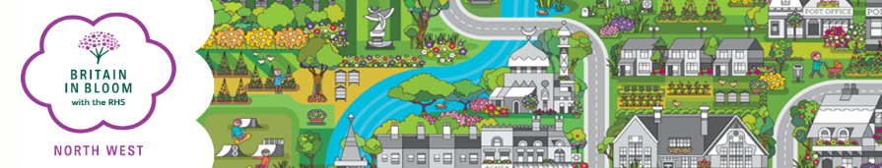

For Admin Only
Group:
Entry:
Key Contact:
Area:
Co-ordinator:
Paid:
Status:

BRITAIN IN BLOOM NORTH WEST ENTRY FORM 2022

Please note:
A unique contact is required for each group that enters.

Entry…….......................................................................................
This is the name that will appear on any award/certificate you may receive.

Contact Name…………………………...................... Position……………………………………………….........

Address………………………………...........................................................................................

Post Code……………………. Tel No……………………………...............Mobile …………………………….…………

E-mail…………………………………………………………………….…………..…..

BRITAIN IN BLOOM CATEGORIES
CATEGORY | ELECTORAL ROLL NOs | CHARGE | TICK
Large City/MBC | over 200,001 | £240.00
City | 100,001 - 200,000 | £240.00
Small City | 35,001 - 100,000 | £225.00
Large Town | 12,001 - 35,000 | £160.00
Town | 6,001 - 12,000 | £130.00
Small Town | 2,501 - 6,000 | £110.00
Large Village | 1,001 - 2,500 | £75.00
Village | 301 - 1,000 | £70.00
Small Village | 300 and under | £55.00
Small Coastal Resorts | 0 - 20,000 | £150.00
Large Coastal Resorts | 20,001 and over | £210.00
Urban Community | 2,500 and over | £160.00
Town/City Centre | - | £110.00
Business Improvement District (BID) | - | £110.00
Local Authority Parks Large |  | £110.00
Local Authority Parks Small |  | £100.00
Pocket Park |  | £55.00

Payment (please tick):
Cheque/s payable to NORTHWEST IN BLOOM □
BACs payment : Account No. 10071623 Sort Code: 16-19-31 □

Please return (preferably by e-mail) by 31st March 2022 to:

Regional Organiser,
Rural Business Centre, Myerscough College, Bilsborrow, Preston, Lancashire, PR3 0RY.
Tel: 01995 642101
E-mail: info@northwestinbloom.com

