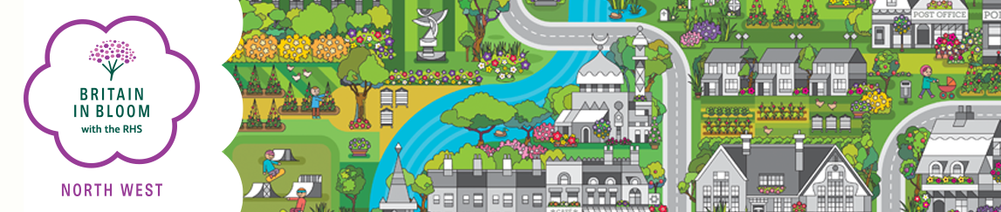
RHS It’s Your Neighbourhood (IYN) Entry Form 2023
For Admin Only
Group:
Entry:
Key Contact:
Area:
Co-ordinator:
Paid:
Status:

Please note:
A unique contact is required for each group that enters.

Name of Entry
This is the name that will appear on any award/certificate you may receive.

Post Code of Entry (for location of the site) ………………………………………….

Contact Name… Position………………………………………………….........

Address………………………………………………………………………………………………………..

Post Code…… Tel No……………………………............... Mobile ……………………………………

E-mail …………………………………………………………………….…………..…..

RHS IT’S YOUR NEIGHBOURHOOD AWARDS
Please indicate the category in which you wish to be assessed

Category | Charge | Please Tick
Neighbourhood | No Fee
Hospice / Residential Home | No Fee
Railway Station | No Fee

Please return (preferable by e-mail) by 31st March 2023 to:

Regional Organiser,
Britain in Bloom North West
Rural Business Centre, Myerscough College,
Bilsborrow, Preston, Lancashire PR3 0RY

Tel: 01995 642101

E-mail: info@northwestinbloom.com

